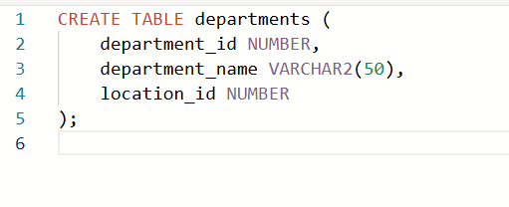

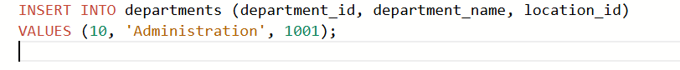

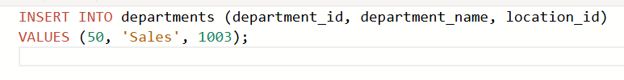

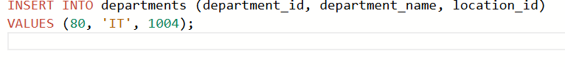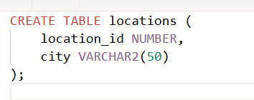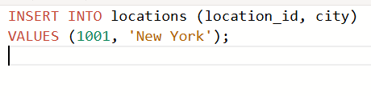

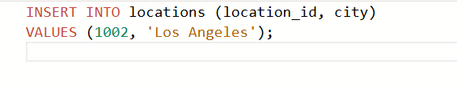

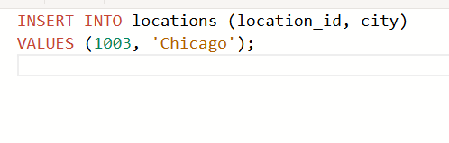

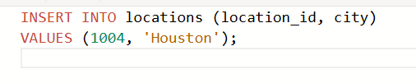

1.. Create a cross-join that displays the last name and department name from the employees and

departments tables.

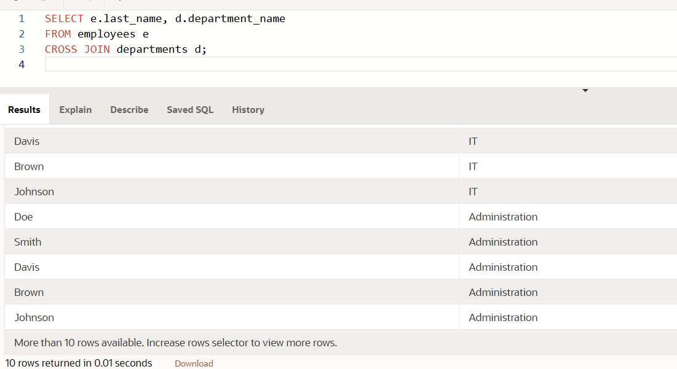

2. Create a query that uses a natural join to join the departments table and the locations table.

Display the department id, department name, location id, and city.

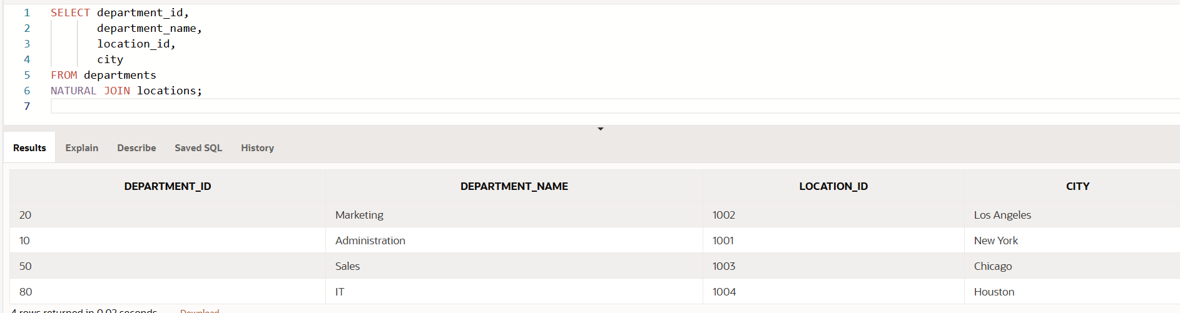

3. Create a query that uses a natural join to join the departments table and the locations table.

Restrict the output to only department IDs of 20 and 50. Display the department id, department

name, location id, and city

